**The Science of Singing: Examining the Physiological and Psychological Benefits of Song**

**Xu, J. (2025). The science of singing: Examining the physiological and psychological benefits of song. *The Journal of Young Innovators, 1*(1), 89–99.**

1. **Abstract**

This article explores the physiological and psychological benefits of signing as a method of anxiety management and stress reduction. The article consults literature from the fields of medicine and biology to demonstrate the neuroscientific principles behind this calming process, looking specifically at vagal nerve stimulation, improved pulmonary functionary, and balanced heart rate variability, all of which contribute to a relaxed and clear mental state. Then, turning to the scholarship within social psychology, this paper examines how singing can be used to promote self-efficacy, reduce feelings of performance-based pressure, and create a felt sense of belonging—all of which effectively lessen social anxiety. This point is supported by key studies within psychology that argue that social connection is a critical component of long-term happiness and stress reduction. The paper concludes that because singing is a widely accessible low-cost activity nearly everyone can engage in, it represents a viable solution for improved mental health. It moreover argues that as a result of the easy-to-implement nature of this activity, singing can lead to positive changes to one’s mental health that are sustainable in the long term.

Keywords: Singing, Stress Reduction, Parasympathetic Nervous System, Social Anxiety, Mental Health

1. **Introduction**

A recent 2021 Gallup Poll reports that four in ten adults worldwide report experiencing a significant amount of worry and stress1. This figure was about the same for Americans, with the American Psychological Association estimating that as of the 2023 “Stress in America” survey, more than 43% of adults claimed to have experienced more stress than the year before2. Within this population, young people are particularly affected by increasing stress and anxiety levels. In another Gallup Poll of 2400 college students, conducted in March 2023, 66% of students reported feeling stressed and 51% reported feelings of anxiety3. Given these statistics, it is safe to say that increased stress is a pressing problem for people throughout the world, leaving many to wonder about the best ways to manage it.

For many in the healthcare sector, pharmacological methods represent a possible solution. Anti-depressants, including selective serotonin reuptake inhibitors (SSRIs) and serotonin-norepinephrine reuptake inhibitors (SNRIs), and various anti-anxiety medications are often offered as a first line of treatment for those suffering from stress and anxiety. However, many of these medications are accompanied by several side effects and even come with more serious considerations for addiction or dependency4. These concerns have led others to turn to alternative ways for managing and reducing stress and anxiety, including incorporating more exercise into daily routines5, practicing healthier sleep habits6, and even engaging in mindfulness activities7. With all of these recommendations, though, the person is being asked to make a major change within their daily life. But what if they did not have to make a significant change? What if, instead, all an individual needed to do to reduce their stress and ease anxiety was leverage the activities they are already involved in? These are the questions behind this report on the psychological and physiological benefits of singing. Whether done solo in the privacy of one’s own home, or in a group setting such as in a school or church choir, as this article will show, the simple act of singing has the power to exert a significant improvement on one’s mental well-being.

In order to support this argument, the following discussion begins with the physiological benefits of singing, addressing the mind-body connections that lead to a calmer mental state. In the following section, it addresses how singing can be used as a tool for combating social anxiety. Within this same section, it introduces current scholarship speaking to the benefits—both physical and mental—of group-based singing activities, such as choir, musical theater, acapella groups, opera ensembles, and more. Collectively, these individual points help the reader to arrive at the logical endpoint of this report, which is that changes that lead to less stress and anxiety are much more sustainable when someone is not asked to make major lifestyle overhauls, but to tap into something the majority of people can do with little effort, training, or skill.

* 1. **The Physiological Pathways to Calmness**

One of the primary benefits of singing has to do with its calming effects. For many, this may be common knowledge as parents singing lullabies to young children to pacify them frequently appears in the cultural narratives, media, and even one’s own upbringing. But with these examples, the focus is on the recipient of the song as opposed to the singer themselves. The act of singing, or even humming if one does not feel they are musically inclined, has been shown to stimulate the vagus nerve, which plays a key role in regulating the parasympathetic nervous system. The parasympathetic nervous system is responsible for counteracting the infamous “flight or fight” response of the sympathetic nervous system, which affects a wide variety of bodily systems, including digestion, diversion of blood supply, breathing, heart rate, and recovery. In short, stimulating the vagus nerve (through singing or humming, for example) may help effectively quiet the body’s natural defense mechanisms.

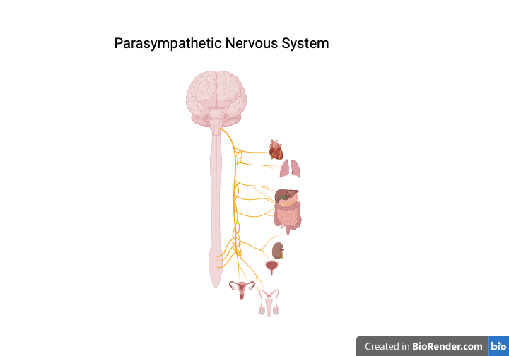

*Figure 1: Illustration of the Parasympathetic Nervous System and the Organs It Affects*

These conclusions are well-documented within the scholarly literature on the topic. For example, a study recently published in the *Journal of Ayurveda and Integrative Medicine* found that humming led to an increase in activity within the parasympathetic nervous system8. This is why people practicing meditation engage in chants like reciting a collective “om” (or *aum*) find that it aids in entering and deepening relaxing states. Such findings are not only supported by centuries of folk knowledge derived from spiritual and religious communities, but empirical studies in the present day. For example, one study from the *Indian Journal of Physiology and Pharmacology* noted changes to the autonomic nervous system (which is composed of the sympathetic and parasympathetic nervous systems) in the form of reduced heart and respiratory rate, both of which indicate the parasympathetic nervous system asserting dominance of the sympathetic one9. More recently, in 2018, a study used an electroencephalogram (EEG) to measure brain activity while participants engaged in an Om-based meditation10. Findings from their spectral analysis noted increased alpha wave activity, suggesting a relaxed yet alert mental state—findings that were corroborated by participants’ own reports.

While these studies focused on the anxiety- and stress-busting qualities of chanting “om,” specifically, it is not the content of the words that matter, but the act of chanting or singing itself. This is supported by a comparative study by Bernardi et al. that investigated the effects of reciting the rosary prayer versus yoga mantras on autonomic cardiovascular rhythms11. In both cases, it found that these practices can have a positive influence on heart variability, an important indicator of balance within the autonomic nervous system and overall cardiovascular health. As Jerath et al. point out, it is the prolonged exhalation that occurs while humming, along with the vibration of one’s vocal cords, that promote healthy and stable heart rate variability12.

Outside of what singing, humming, chanting does for the nervous and cardiovascular systems, it also holds immense benefits for an individual’s pulmonary health. The act of singing requires that a person activate the diaphragm and the intercostal muscles. The diaphragm is a group of muscles located just under the lungs. When the lungs inhale to fill with air, the diaphragm contracts, moving downward and making space for the lungs to expand. On exhalation, the contraction releases and the muscles move upwards, pushing the air out. The intercostal muscles, located between the ribs, assist with this process. External intercostal muscles help to lift the rib cage up and out, while the internal intercostals facilitate exhalation. Together, the diaphragm and intercostal muscles play an important role in pulmonary health. McCool and Tzelepis noted that dysfunction of the diaphragm impedes lung performance and function13. The strength and coordination of the diaphragm and intercostal muscles is imperative to proper pulmonary functioning during times of great physical activity or stress.

The research on the physical benefits of the muscles groups strengthened by singing is quite clear, but there is significant evidence that suggests that this improved pulmonary function may also result in improved mental health as well. Take the example of breathwork, which has become increasingly popular in recent years as a relaxation tool. The core principle of breathwork is to use your own breathing as a calming method. The techniques used in breathwork practices vary, but common ones include diaphragmatic breathing (also known as belly breathing), where you take slow, deep breathing. Another popular technique is called box breathing, where you inhale, hold, exhale, and hold for equal durations. Regardless of the technique, though, deep breathing—such as what is achieved with singing—encourages the release of endorphins. Often referred to as the “feel good” hormone, endorphins are described as the body’s natural painkiller and mood-booster14.

These are just a few examples of how the act of singing (or humming or chanting) can positively impact an individual’s physical as well as their psychological health. As the mind-body connection is coming to be better understood within the scientific community, researchers are starting to unearth how this activity, which benefits the nervous, cardiovascular, and pulmonary systems, translates into an effective antidote to high stress and anxiety levels.

1. **Singing Through the Fear: Group Performance and Social Anxiety**

2.1. **Public Singing Versus Public Speaking**

Anxiety can come from many sources. One of the most common sources of anxiety stems from social anxiety, which can lead to social anxiety disorder (SAD). The *Diagnostic and Statistical Manual of Mental Disorders (DSM)- V* (2022) defines SAD as “marked fear or anxiety about one or more social situations in which the individual is exposed to possible scrutiny by others”15. The *DSM-V* provides common examples when one may experience social anxiety, including meeting new people, having a conversation with another person, eating or drinking in public, or even performing in front of others. The last of these occasions would encompass singing-based performances, such as those that one delivers as part of a choir or musical ensemble, inviting the counterintuitive question, “Since singing as a part of a choir or organization gives regular public performances, wouldn’t this increase social anxiety?”

There are actually many reasons why the same individual who experiences heightened social anxiety during public speaking would not experience a similar degree of anxiety with singing. For one, whether an individual is part of a choir, barbershop quartet, musical theater troupe, or acapella group, they are in a group setting, and this is key to combating the anxiety-inducing effects of a public performance. In these settings, there is what social psychologists refer to as a “diffusion of responsibility.” This term comes from the work of the well-known social sciences and learning researcher, Albert Bandura. Bandura claimed that being in the presence of others makes an individual feel less responsible for their actions16. If a group singing is off tempo or pitch, or if the performance is otherwise seen as unsatisfactory, the individual alone is not to blame because the performance is the result of collective efforts. Therefore, while it may initially appear counterintuitive, singing in a group setting may function to reduce, as opposed to induce, social anxiety.

Additionally, performances within these specific contexts often involve acting out a role or bringing a song, story, or character to life. Since what is being delivered to the audience is not one’s own personal thoughts or beliefs, the performer may feel less subject to scrutiny and therefore less anxious. The logic behind this is that the audience may not like the score for *Les Miserables* or may find John Lennon’s “Imagine” too cliché, yet that is not the fault of the individual performer, but rather the composer.

On a related note, much of the material choir singers and musical performers work from is very rehearsed. With ample opportunities to practice, the performer may feel more confident in their abilities to do so in a public setting. Bandura’s theories of social learning are once again helpful in understanding the underlying psychological processes in which anxiety is lessened through repeated practice or rehearsal. Bandura developed a theory of self-efficacy, which refers to a person’s belief in their ability to perform a task17. Bandura states that people gain a sense of self-efficacy from “mastery experiences.” Mastery experiences refer to occasions where a person has successfully completed a task before, leading them to believe in their ability to do the same again. If a performer was able to successfully deliver a song in rehearsals, they may gain a sense of self-efficacy, believing they can do it again during live performances. But more importantly, repeated successful performances lead to increased self-efficacy, which has been proven in the academic literature to reduce the effects of stress and anxiety.





*Figure 2: Sources of Self-Efficacy18*

In a 2003 study by Bandura et al., the authors state conclusively, “Perceived self-efficacy was inversely related to anxiety levels in individuals with GAD [generalized anxiety disorder]”19. This statement was similarly supported by another study from the same year by Gaudiano and Herbert. The researchers were investigating the relationship between self-efficacy and social anxiety disorder. They measured participants’ self-efficacy before and after receiving cognitive behavioral therapy (CBT), and discovered that those who reported increased self-efficacy also experienced significantly fewer anxiety-related symptoms20. When taken together, these studies suggest that the social settings in which singers repeatedly deliver successful performances may actually diminish social anxiety rather than contribute to it.

* 1. **Group Harmony and the Social Benefits of Singing**

The social aspect of singing in a choir or ensemble offers more psychological benefits than just those that come with group performances. It also offers an invaluable opportunity for individuals to build their social networks. There is a vast body of research supporting this claim, but one of the most well-known of all of these is the Harvard Study of Adult Development. What separates this study from others like it is that it was a longitudinal study tracking adults’ reported happiness across their lifespan. The study began in 1938 and followed 724 men (later expanding to include their spouses and children) throughout their lives. The researchers found that a strong social network helped with regulating stress, with relationships essentially acting as a buffer for life’s stressors21. Dr. Robert Waldinger, the lead researcher for the study summed up the significance of these findings as this: “Good relationships keep us happier and healthier. Period”22. Given these findings, if someone is looking to lead a healthier, happier life, joining a school choir or musical theatre troupe may go a long way towards achieving these goals.

But it is not just close relationships that have a positive impact, providing further proof that even those casual acquaintances someone makes from once-a-week rehearsals would be helpful. Sandstrom and Dunn’s (2014) research on the power of weak ties supports this point23. The authors argue that even casual (i.e., not very meaningful) interactions with others can positively impact people’s psychological health. The “weak ties” that a person creates with the others involved in their singing groups and musical organizations therefore can be a powerful source of stress reduction and happiness promotion.

All of these studies mentioned provide empirical support for the claim that group-based singing activities reduce stress and improve mental health for those involved. Yet, there are also theoretical components that are worth considering. For example, one of the most well-known explanations of how humans are motivated by a complex set of both physiological and psychological needs is Maslow’s Hierarchy of Needs24. Maslow’s Hierarchy of Needs is organized as a pyramid, with the most basic physiological needs (i.e., water, food, shelter) at the base. Higher up, towards the middle of the pyramid, is the need for belongingness. One could argue that choir and other similar activities provide an opportunity for meeting this need, and that participating in such activities therefore reduces the stress of attempting to have this need met.

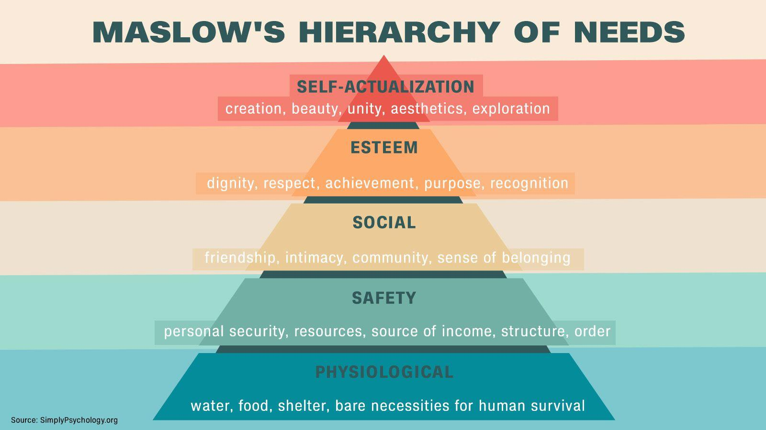

*Figure 3: Maslow’s Hierarchy of Needs*25

At its core, Maslow’s Hierarchy of Needs acknowledges that humans are fundamentally social animals. There is an evolutionary basis to this claim. In early societies, the people who lived in social groups had a better chance of survival and reproduction26. Having a social network like this would help the individual share resources like food and shelter, and collectively defend against enemies and predators. This is why many psychologists link this evolutionary drive to social anxieties today. Leary and Cottrell adopt this stance, stating that “establishing and maintaining relationships with other people was among the most crucial tasks faced by our evolutionary ancestors”27. They also claim that humans developed several psychological adaptations for dealing with the fear and stress that accompanies social exclusion. Instead of psychological adaptations, however, this report argues that one can make simple, easy-to-implement lifestyles changes that could protect against this fear of exclusion and fill an evolutionary need for social acceptance. One only has to look as far as a school chorus or church choir to find reassurance of their social inclusion.

1. **Conclusion: Small Changes, Big Impact**

One of the primary reasons lifestyle changes fail is because the scope of the change a person is asked to make is too great. For instance, if someone has a goal to lose 10 pounds, asking them to cut out all refined sugars would be a tall order, and is likely not sustainable in the long run. Instead, asking them to cut back on the number of sugary beverages they drink in a day (an incremental change as opposed to a lifestyle overhaul) is much more likely to yield a successful result. The same applies for mental well-being and anxiety and stress reduction. While stress and anxiety levels are on the rise for all age groups, it is especially prevalent among young people. One 2025 CDC survey even found that 29% of students indicated that their mental health was not good most of the time or always in the past 30 days. When thinking about the sorts of changes this population can implement, it makes sense to consider feasibility.

For this population, and for many others, seeking pharmacological solutions to stress, anxiety, and general unhappiness may not be reasonable due to barriers associated with the cost of medication or underlying conditions that prevent them from taking these medicines. Additionally, joining a gym or wellness studio might also not be feasible as some young people may lack access to transportation or are under the legal driving age. However, most schools offer some form of singing club or activity, whether that is a simple music class, a choir, or quarter group. Any of these could be easily added into the student’s after-school line-up for little to no cost and would place limited demands on their transportation. In joining these clubs or participating in these activities, the student stands to reap the benefits of a social network, which the research has shown reduces anxiety and stress and increases overall happiness.

If group-based singing activities are not an option, there are still ample psychological benefits the individual can incur from solo singing. This report explored the mind-body connection with regard to singing, showing how it stimulates the vagus nerve to balance the autonomic nervous system and strengthening the cardiovascular and pulmonary systems for greater relaxation. Taking all that the research has to say on this topic, happiness may be seen not as some elusive lifelong goal, but easily attainable in the near future.

1. **References**
2. J. Ray. Negative emotions reached a record high in 2021. *Gallup Global Emotions Report*. https://www.gallup.com/analytics/394280/global-emotions-2022.aspx (2022).
3. American Psychological Association. Stress in America 2023: A nation recovering from collective trauma. *American Psychological Association*. (2023). <https://www.apa.org/news/press/releases/stress/2023/collective-trauma-recovery>
4. Z. Hrynowski, S. Marken, College students experience high levels of worry and stress. Gallup. <https://www.gallup.com/education/509231/college-students-experience-high-levels-worry-stress.aspx> (2023).
5. G. A. Fava.Rational use of antidepressant drugs. *Psychother Psychosom.* **87**, 193–204 (2018). <https://doi.org/10.1159/000491524>
6. E. Anderson, G. Shivakumar. Effects of exercise and physical activity on anxiety. *Front Psychiatry.* **4**, 27 (2013).
7. V. Alfonsi, S. Scarpelli, A. D’Atri, G. Stella, L. De Gennaro. Later school start time: The impact of sleep on academic performance and health in the adolescent population. *Int J Environ Res Public Health*. **17**, 2574 (2020).
8. S. G. Hofmann, A. T. Sawyer, A. A. Witt, D. Oh. The effect of mindfulness-based therapy on anxiety and depression: A meta-analytic review*. J Consult Clin Psychol*. **78**, 169–183 (2010).
9. A. Chandran, M. Vinothkumar, R. V. Prabhu, R. Balasubramanian. Effect of Bhramari pranayama on heart rate variability among healthy individuals: A randomized controlled trial. *J Ayurveda Integr Med.* 100732 (2023).
10. S. Telles, R. Nagarathna, H.R. Nagendra. Autonomic changes during "OM" meditation. *Indian J Physiol Pharmacol.* **39**, 418–420 (1995).
11. B.P. Harne, A.S. Hiwale. EEG spectral analysis on OM mantra meditation: A pilot study. *Appl Psychophysiol Biofeedback.* **43**, 123–129 (2018). https://doi.org/10.1007/s10484-018-9391-7
12. L. Bernardi, P. Sleight, G. Bandinelli, S. Cencetti, L. Fattorini, J. Wdowczyc-Szulc, A. Lagi.

Effect of rosary prayer and yoga mantras on autonomic cardiovascular rhythms: Comparative study. *BMJ.* **323**, 1446–1449 (2001).

1. R. Jerath, C. Beveridge, V. A. Barnes. Self-regulation of breathing as a primary treatment for anxiety. *Front. Hum. Neurosci.* **12**, 397 (2018).
2. F. D. McCool, G. E. Tzelepis. Dysfunction of the diaphragm. *N Engl J Med*. **366**, 932–942 (2012).
3. S. Watson. Serotonin: The natural mood booster. Harvard Health Publishing. (2023, November 20). Available at: <https://www.health.harvard.edu/mind-and-mood/serotonin-the-natural-mood-booster>
4. American Psychiatric Association. Diagnostic and statistical manual of mental disorders (5th ed., text rev.). American Psychiatric Publishing (2022).
5. A. Bandura. Social cognitive theory of self-regulation. *Organ Behav Hum Decis Process*. **50**, 248–287 (1991).
6. A. Bandura. Self-efficacy: Toward a unifying theory of behavioral change. *Psychol Rev.* **84**, 191–215 (1977).
7. A. Kundu. Toward a framework for strengthening participants' self-efficacy in online education. *Asian Assoc Open Univ J.* **15**, 351–370 (2020).
8. A. Bandura, G. V. Caprara, C. Barbaranelli, M. Gerbino, C. Pastorelli. Role of affective self‐regulatory efficacy in diverse spheres of psychosocial functioning. *Child Development*. 74, 769–782 (2003).
9. B. A. Gaudiano, J. D. Herbert. Self-efficacy for social situations in adolescents with generalized social anxiety disorder. *Behav. Cogn. Psychother.* **35**, 209–223 (2007).
10. M. Solan. The secret to happiness? Here's some advice from the longest-running study on happiness. Harvard Health Blog (2017), (available at <https://www.health.harvard.edu/blog/the-secret-to-happiness-heres-some-advice-from-the-longest-running-study-on-happiness-2017100512543>).
11. R. Waldinger. What Harvard’s Study of Adult Development reveals about happiness. *Robert Waldinger.* (2024, Oct. 22). <https://www.robertwaldinger.com/post/what-harvard-s-study-of-adult-development-reveals-about-happiness>
12. G. M. Sandstrom, E. W. Dunn. Social interactions and well-being: The surprising power of weak ties. *Pers Soc Psychol Bull.* **40**, 910–922 (2014). <https://doi.org/10.1177/0146167214529799>
13. A. H. Maslow. *Motivation and personality.* Harper & Row (1954).
14. B. Sloane. Maslow's hierarchy of needs explained. *CNN.* (2024, Apr. 24). <https://www.cnn.com/world/maslows-hierarchy-of-needs-explained-wellness-cec>
15. E. Aronson. *The social animal* (12th ed.). Worth Publishers (2018).
16. M. R. Leary, C. A. Cottrell. Evolutionary perspectives on interpersonal acceptance and rejection. In C. N. DeWall (Ed.), *The Oxford handbook of social exclusion* (pp. 9–19). Oxford University Press (2013).